

**Communication Audit Final Report**

Group 7 – Cinco PR

Client – Saltaire Brewery

Tutor – Shirley Beresford

**Submission: 11th January 2015**

This final report was created by Cinco PR and outlines the communications audit project the agency has undertaken for Saltaire Brewery. The report gives an overview of Saltaire Brewery and its target audiences, recaps the brief’s objectives and describes the methodology used. This report will also discuss the findings and recommendations and put forward suggestions for budgets, timescales and resource options.

**Acknowledgement**

Cinco PR would like to thank Shirley Beresford and Wendy Carthew for giving the group the opportunity to undertake the communications audit project for Saltaire Brewery. The agency wishes to express their sincere gratitude for the guidance and assistance throughout the process.

**Contents**

**1.0 Cinco PR**

1.1 Meet the team

1.2 Job roles

1.3 Contact details

**2.0 Overview of Client**

**3.0 Overall Business Goals**

3.1 Communications objectives of the business

**4.0 The Brief**

4.1 Aims and objectives of the brief

**5.0 Stakeholders**

**6.0 Timeline of Activity**

**7.0 Preliminary Research – SIBA**

**8.0 Primary Research Methodology**

**9.0 Findings**

9.1 Beer Club

9.2 Consumer interviews

9.3 Customer interviews

9.4 Website development

**10.0 Secondary Research Methodology**

**11.0 Findings**

11.1 Competitor research

11.2 Website analysis

11.3 Social media analysis

**12.0 Cinco PR Recommendations**

12.1 Website

12.2 Events

12.3 Social media

**13.0 Creative Content**

13.1 Bake Off

13.2 Summer Solstice Beer Club

**14.0 Timeline for Recommendations**

**15.0 Evaluation**

**16.0 Resources**

**17.0 Additional Research Methods**

**18.0 Bibliography**

**19.0 Appendices**

**1.0 Cinco PR**

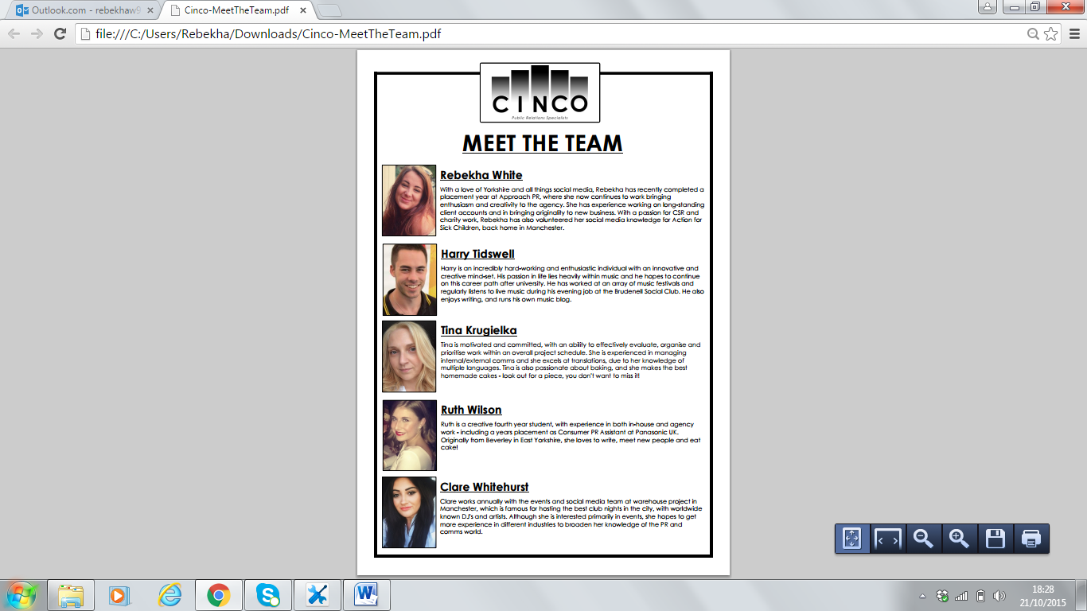1.1 Meet the team

1.2 Job roles

Rebekha White – Team manager and client liaison

Harry Tidswell – Design and research executive

Clare Whitehurst – Research executive

Ruth Wilson – Tutor liaison

Tina Krugielka – Administrative and research executive

1.3 Contact details

Cinco PR:

Rebekha White - R.white9242@[student.leedsbeckett.ac.uk](http://student.leedsbeckett.ac.uk/)

Ruth Wilson - [R.wilson9663@student.leedsbeckett.ac.uk](mailto:R.wilson9663@student.leedsbeckett.ac.uk)

Tina Krugielka - [T.Krugielka2976@student.leedsbeckett.ac.uk](mailto:T.Krugielka2976@student.leedsbeckett.ac.uk)

Clare Whitehurst - [C.whitehurst9638@student.leedsbeckett.ac.uk](mailto:C.whitehurst9638@student.leedsbeckett.ac.uk)

Harry Tidswell - [H.tidswell2292@student.leedsbeckett.ac.uk](mailto:H.tidswell2292@student.leedsbeckett.ac.uk)

Tutor: Shirley Beresford at Leeds Beckett University: [s.beresford@leedsbeckett.ac.uk](mailto:s.beresford@leedsbeckett.ac.uk)

Client: Wendy Carthew at Saltaire Brewery: wendy.carthew@saltairebrewery.co.uk

**2.0Overview of client**

* Saltaire Brewery is an international award-winning brewery located in Shipley, West Yorkshire.
* Formed in 2005, it began creating hand-crafted ales in 2006.
* Saltaire Brewery’s ales have won more than 70 trade awards including two national championship brews and two international gold medals for its Triple Chocoholic Stout.
* The Brewery produces more than 600 casks each week making up more than 70% of its sales.
* The Saltaire Blonde is a permanent ale on over 200 bars and pubs all over Yorkshire, the North West, Cumbria and the North East.
* Bottled beers are also available in most major supermarkets in Yorkshire with 30% of its total sales being made up of this.
* With Saltaire Brewery’s ever-changing range of seasonal and special beers, the brewery also distributes to specialised off licenses.
* The brewery’s recent growth in demand has led to an increase from 8 to 10 brews a week.
* Members of the Society of International Brewers
* Saltaire Brewery is also home to well-known monthly Beer Club and regular Trade Nights.
* With its strong Yorkshire presence, the brewery is beginning to develop its national and international reputation.
* Saltaire Brewery has over 3,650 likes on Facebook and over 17.3K followers on Twitter.

**3.0 Overall Business Goals**

*“A business aim is the goal a business wants to achieve. A primary aim for all business organisations is to add value and in the private sector this involves making a profit. More strategic aims include expansion, market leadership and brand building”*

(Business Case Studies)

Saltaire Brewery’s main business objectives are:

* Respond to the increase in demand by doubling the amount of brews to 20 per week in 2016
* Double the number of barrels made per week from 20 to 40 in 2016
* Expand the brewery’s distribution and market area over the next 12 months
* Explore e-commerce opportunities as part of improving the website’s ability to engage with customers and consumers

3.1 Communications objectives of the business

Saltaire Brewery’s current broad communication objectives are:

* Reach audiences outside of Yorkshire including the Midlands and London
* Strengthen both current B2B customer and end user consumer relationships through online media
* Increase online presence over the next 12 months
* Develop the brewery’s national and international reputation

**4.0 The Brief**

Saltaire Brewery commissioned Cinco PR to undertake a communications audit of its website and social media content looking specifically into interactivity and engagement with its B2B customers and end user consumers. The Brewery commissioned Cinco PR to develop a strategic picture of communication that will assist its business to grow, improve ecommerce and develop markets in the next 12 months.

4.1 Aims and objectives of the brief

1. To explore the potential to build on online engagement through social media and the website
2. To make recommendations for improvements to the website in order to match new branding
3. To explore how current customer relationships can be strengthened through social media
4. To identify all audiences and their online preferences to target them on a more personal level
5. To research new social media channels to place product in the eyes of new customers
6. To undertake competitor research on 4 of Saltaire Brewery’s main competitors with a focus on marketing methods

**5.0 Stakeholders**

*“Contemporary organizations increasingly realize that they need to communicate with their stakeholders to develop and protect their own reputations”*

(Cornelissen, 2011:39)

Cinco PR identified the following as Saltaire Brewery’s key target audiences.

|  |  |
| --- | --- |
| **Off Trade Customers** | Asda (Primary supplier)  Co-Op (Secondary supplier)  Waitrose (Saltaire Brewery’s only national supplier)  Additional regional supermarkets  Off licenses and independent shops |
| **On Trade Customers** | Pubs, bars and restaurants  Saltaire Brewery supply cask ales to over 200 public houses |
| **End User Consumers** | Members of the general public:   * Bottles can be bought from public houses, supermarkets, and online through a third party * Cask ales can be bought from public houses * Saltaire Brewery’s consumers are of all genders and ages (18+) |
| **Internal Audience** | Staff:   * Tony Gartland – Owner * Derek Todd – Director of Brewing * Ewen Gordon – Managing Director * Wendy Carthew – Marketing Manager * Other staff – Brewers, Sales Team, etc. |
| **Independent Professional Body** | SIBA – Society of Independent Brewers |

**6.0 Timeline of Activity**

|  |  |
| --- | --- |
| Date | Activity |
| 13Th October 2015 | Briefing meeting at Saltaire Brewery 10am with Wendy Carthew and Cinco PR |
| 30th October 2015 | Proposal and ethics form submission |
| 30th October 2015 | Vox Pops and Observational Research at The Beer Club 30th October |
| w/c 9th November 2015 | Content analysis on social media channels, websites and competitor research |
| w/c 16th November 2015 | On trade customer and end user consumer interviews  Meeting with freelance web developer |
| w/c 23th November 2015 | Data analysis and creative recommendations |
| w/c 30nd November 2015 | Presentation and report creation |
| w/c 7th December 2015 | Presentation rehearsal with Shirley Beresford at Leeds Beckett |
| w/c 21th December 2015 | Final presentation at Saltaire Brewery at 11am on 21st December 2015 |
| 11th January 2016 | Final report submission 12pm |

**7.0 Preliminary research – SIBA**

SIBA is the Society of Independent Brewers which manages the interests of independent breweries in the UK representing more than 825 independent craft breweries. The organisation’s vision *“is to deliver the future of British beer and become the voice of British brewing.”*

(SIBA.com, 2015)

SIBA’s annual beer report 2015 findings are:

* Beer production was estimated to have increased by 15.8% from 2013-14
* Average beer strength is 4.1% ABV
* Golden ales are the most produced beer style, followed by traditional bitter
* Most brewers produce between 4 to 6 regular brands with 90% of respondents also brewing seasonal beers
* 83% of brewers plan to recruit one or more new employees in the next 12 months
* 1 in 4 employees are female
* 1 in 10 employees are aged 16-24
* 3 out of 4 respondents expect their turnover increase in 2015
* Over 80% of beer sold within 40 miles of the brewery
* Almost one out of five breweries plan to double their current levels of production, sales and turnover by 2018

(The Beer Report, 2015)

**8.0 Primary Research Methodology**

To fulfill objectives three and four Cinco PR conducted primary research using a number of methods. Primary research involves obtaining new data (Saunders et al, 2012: 304) and we did this through vox pops, observational research and both on trade and end trade consumer interviews.

We conducted Vox Pops, considered to be a form of convenience sampling (Saunders et al, 2012: 291) due to the convenience of the cases selected for interview at random. The Vox Pops were carried out during October’s Beer Club and we obtained qualitative data from attendees through general comments regarding what they would like to see on social media from Saltaire Brewery. While convenient, a limitation of Vox Pops is that they are prone to bias and influences beyond the researchers’ control, therefore generally speaking have little credibility (Saunders et al,291).

During our attendance at the Beer Club on 30th October we also carried out observational research, identifying three core ale drinking groups. In this research exercise we acted as observers, meaning that the subjects were unaware as we observed them in an unobtrusive way (Saunders, 2012: 345). Similar to the data obtained through Vox Pops, our observational research provided us with further qualitative data, as the groups identified were as follows: middle aged females, young men and older gentlemen.

Through our attendance at the Beer Club, our awareness and knowledge of Saltaire Brewery and their wide customer base was heightened. Observations can often pose ethical issues (Saunders, 2012: 355) however we had received ethical approval and gained permissions from the brewery to observe attendees.

We also conducted semi-structured interviews which entail the researcher having a list of themes and key questions which can vary from interview to interview (Saunders: 2012, 374). The semi-structured format meant that we were able to probe further and find out why interviewees felt how they did about the topic of discussion. Interviews also allow for the conversation to lead to significant areas which hadn’t been considered previously (Saunders et al, 378). We interviewed both on trade customers, which are the pubs and bars which stock Saltaire Brewery’s products and end user consumer groups; the general public who buy them.

**9.0 Findings**

9.1 Beer Club

Cinco PR attended the Beer Club hosted by Saltaire Brewery on the 30th of October. The Beer Club is a monthly event which attracts a large number of consumers. Cinco PR gathered data at the event through observation and vox pop research. To gather general comments from the public, Cinco PR asked three questions to gain the views and opinions of the consumers.

Questions

1. Are you on social media?
2. If so, what platforms?
3. What content would you like to see from Saltaire Brewery on its social media channels?

Key findings

* A large variety of ale drinkers, different ages, genders and occupations.
* Around ¾ of participants were on social media with Facebook and Twitter being most used. Instagram was also very popular.
* Main interests: Promotions, events, special brews, and the brewing process.

Cinco PR identified a diverse range of ale drinkers who attended the Beer Club. Cinco PR’s findings shaped the recommendations to fit a wide target audience.

9.2 Consumer Interviews  
Saltaire Brewery identified consumers as the ‘end-users’ of their product. Cinco PR conducted interviews with six consumers from varied target demographics. The agency undertook interviews with representatives from the three core audience groups. These were different genders and age ranges in order to achieve triangulation in our research, and gain a more comprehensive representation of Saltaire’s consumer-base (Cohen and Manion, 2000).

Cinco PR identified consumer’s opinions on how brands can improve on social media by posting more interesting and personal content. Interviewees expressed that they were discouraged by ordinary promotional material and are more engaged by competitions, event-focused content, and information on where the products are available. Cinco PR found that around 66% of the consumers interviewed follow food and drink brands on Instagram.  
  
Interviewees also highlighted that they greatly value the design and efficiency of a brand’s website, and that a brand’s website can sometimes - positively or negatively - alter their opinion of an organisation. Participants also identified the reason why they visit brand’s websites is in order to read information about products and to order.

Consumers stated that they tend to visit social media pages for news or recent information, whereas they tend to visit a brand’s website for detailed information on the brand or its products. Consumers also unanimously expressed interest in events held by food and drinks brands, citing it as an opportunity to try new products.

9.3 Customer interviews

Saltaire Brewery identified their customers as the direct buyers of their product, such as; public houses, bars, supermarkets, and ale shops.  
  
Cinco PR conducted interviews with two managers of a public house and a bar in the Leeds area, who commonly stock Saltaire Brewery’s products.

Cinco PR found that customers ordered Saltaire Brewery’s products via the phone, but would be encouraged to make orders more often if they could use an online method. The stockists also claimed that the things they most value when engaging with beer brands on social media included “two-way communication” and the recognition of selling a brand’s product. They also stated that the main reason that they visit a brand’s website is to find information on new products.  
  
The two interviewees agreed on the positive effect that events have on the amount of interest shown to brand by consumers. One customer also expressed following an event they often restock products by these brands in order to meet demand.

9.4 Website Development

Cinco PR approached freelance website developer Mike Lawton, following his recent project, Headrow House, with Leeds-based design agency duo. The target audience for Headrow House represents one of the three core consumer groups for Saltaire Brewery.

Cinco PR commissioned a meeting with Mike Lawton to learn about website development and discus the following topics:

* Responsive website design
* Interactive features
* Techniques for achieving engagement
* Linking social media to website design
* Ideas on Saltaire Brewery’s website development and current design
* Pricing and timings

**10.0 Secondary research methodology**

To fulfill objectives one, two, five and six Cinco PR conducted content analysis, this was essential to gather the information required to fulfill the brief. Secondary research entails the use of data which is already available (Saunders: 2012, 304) and thus gaining wider knowledge of the area. We carried out content analysis of global beer brands who we felt to be particularly successful in their online presence. On a more local scale, we conducted competitor research to find out what other beer brands were doing on social media and why their websites work, in order to identify ways in which Saltaire Brewery can reach their core business objectives.

Mixed methodology is viewed as being more reliable than the use of only one form of data (McCusker & Gunaydin, 2015: 5) therefore the limited amount of quantitative data within our secondary research could be viewed as a disadvantage thus making our research less reliable. In order for us to adhere to our brief however, we were required to gain data which was inevitably in qualitative form and which played a larger role in the formulation of our recommendations than charts and graphs would have done.

**11.0 Findings**

11.1 Competitor research

We identified Dark Star Breweries, Beavertown Brewery, Ilkley Brewery and Leeds Brewery as Saltaire Brewery’s main competitors. Through analysis of their websites and social media feeds along with other primary and secondary research we were then able to form a basis for our recommendations for Saltaire Brewery’s own website and social media feeds.

**Dark Star Breweries**

Website

* Includes a tool called ‘beerfinder’ which allows consumers to be able to easily find a pint of Dark Star on a map**.** Alsodisplays Pubs/Bars that regularly order Dark Star beer
* Links to their social channels on every page & the option to subscribe to their RSS feed
* Beers can be bought directly from their website in cases, kegs and gift boxes etc. Can also buy more novelty items such as Beer Advent Boxes and a ‘Map of the British Ales’
* Regular posting within their ‘News’ page and also have a ‘Blog’ feature
* Offer brewery tours

Social media

|  |  |  |
| --- | --- | --- |
| **Facebook**  6505 ‘likes’  866 people ‘checked in’  4.8 stars, 274 reviews  Mostly post about events, availability  Very visual and often include photographs | **Twitter**  31.1k followers  Mostly used to inform followers where they can find a Dark Star beer  New brews created  Retweet pubs and consumers | **Instagram**  @darkstarbrewco  859 Followers  Encourage consumers to tag their Dark star beer photos and use the hashtag ‘#brewshots’ to win prizes  Photos of new brews, behind the scenes of the brew house and what their team get up to |

**Beavertown Brewery**

Website

* Busy design
* ‘Other Half Brewing Co’ logo dominates the home page
* Immediately led to ‘blog’ rather than having a home page
* Provide links to websites to order online and to access Twitter feed

Social media

|  |  |  |
| --- | --- | --- |
| **Facebook**  9,095 ‘likes’  2,171 people checked-in  4.9 stars, 142 Reviews  Mostly linked with tweets | **Twitter**  30.3K Followers  Tweet mainly about events and re-tweet what consumers and pubs have tweeted about the brewery | **Instagram**  @Beavertownbeer  9,104 followers  Post about events  Linked to Twitter account |

**Ilkley Brewery**

Website

* Attractive visuals used on the website depicting the brewery with light animation which moves with cursor
* Includes the ‘Beerfinder’ app, as mentioned above re Dark Star Breweries
* Promotion of ‘Have You Seen Mary Jane #Followmary’ campaign
* Can order online from a separate stockist, ‘Beer Hawk’
* News page set out like an old newspaper and very in keeping with the feel of the site, regularly updated and features Twitter feed

Social media

|  |  |  |
| --- | --- | --- |
| **Facebook**  1,857 ‘likes’  54 people checked-in  4.9 stars, 29 reviews  Where to buy the beers  New brews  Very visual with use of pictures | **Twitter**  18.4k Followers  Engage with Twitter users  Suggestions of gifts, in keeping with season  Retweeting pubs and consumers  Local news/flashbacks | **Instagram**  @ilkleybrewery  480 followers  Post about new brews  General info on what’s going on at the brewery  Events |

**Leeds Brewery**

Website

* Attractive yet minimalistic home page, easy to navigate
* Information page on pubs which stock Leeds Brewery beers
* ‘Journal’ page which has reports on lifestyle news from around Leeds
* ‘Meet the team’ section, very

Social media

|  |  |  |
| --- | --- | --- |
| **Facebook**  368 ‘likes’  2 people have checked in  Post about local interests and news  Post about events | **Twitter**  12.2k Followers  Tweet about local interests  News on stockists of beers  Retweet consumers and stockists | **Instagram**  @leedsbrewery  654 Followers  Post about where brews can be bought  Humorous posts related to beer |

11.2 Website Analysis

Additionally, Cinco PR undertook website content analysis on three large beer brand websites to investigate what interactive features they use to engage with their audiences. Cinco PR analysed Guinness, Carlsberg and Heineken.

Guinness:

* Interactive pub finder map
* ‘Join in’ newsletter sign up
* Guinness and Food recipe section
* Interactive timeline
* Lots of video content including ‘how to pull the perfect pint’

Carlsberg:

* Interactive pub finder
* Rate and review feature
* Clear and regular links to social media with a focus on Twitter
* Interactive timeline
* Brand interest: Football

Heineken:

* Split into four different websites: corporate, consumer, trade and star pubs and bar
* Interactive timeline

Summary of large brands

When analysing the three large beer brands, Cinco PR identified the most engaging elements of the three websites along with patterns of repeated features across all.

* Story telling timelines
* Brand interests
* Split websites
* Increased interactive features
* Video content
* Recipes
* Rate and review sections

11.3 International social media analysis

Cinco PR undertook website and social media content analysis on Browar Amber, a polish brewery. Cinco PR identified the brewery as an international match for Saltaire Brewery.

Social media channels:

* Facebook
* Twitter
* Instagram
* YouTube
* Periscope
* Google+
* LinkedIn

Findings:

* The Analytical capabilities, affordability and accessibility allows the brewery to plan and achieve engagement in a short time.
* Browar Amber began with just Twitter and Facebook before extending their social media platforms to continue establishing direct contact with consumers.
* An increasing emphasis on the activity of "real time". An instant reaction and natural conversation is required by both Twitter and Periscope.
* The biggest challenge faced by Browar Amber on social media is the ability to listen to both praise and criticism from consumers.
* Naturalness and sincerity in social media engagement builds value not only for the brand and helped the brewery to develop consumer relations and grow a large audience.
* The brewery identifies each social media channel as a different profile which relates to a specific type of consumer.
* Content ideas are found from observations.
* Browar Amber manages their social media channels both internally and externally through an agency.

**12.0 Cinco PR Recommendations**

12.1 Website

Cinco PR website feature recommendations are as follows:

* Go responsive and ensure the website design is all user friendly
* Split trade and consumer websites to tailor content
* Develop e-commerce to bring in-house
* Make the Beer Club a consumer focus
* Improve website photography
* Consolidate website features
* Add age restrictive entry page
* Use light animation to create an interactive brewing process
* E-newsletter and promotions sign up
* Introduce an interactive ‘beerfinder’

Website Costings

Design costs at £300/day

Photography Costs: £125/hr, £150(2hrs), £300 (half day - 4.5hr), £550 (full day - 9hr)

Development Costs at £360/day

*All costs/timeframes are approximate and subject to changes following a full project briefing & scope discussion.*

|  |  |  |
| --- | --- | --- |
| **Options** | **Costings** | **Time Breakdown** |
| Option 1: Photography, Redesigned & Responsive Rebuild | Photography: 0.5/1 day shoot = £550  Design: 5 days = £1500  Development: 13 days = £4680  *TOTAL = £6730* | Project Setup (0.5 day)  Homepage (1 day)  Beers (2 days)  Beer Club (0.5 days)  The Brewery (About/Staff) (1.5 days) Blog (2 days)  Shop (keep as is - link to 3rd party shop)  Trade area (on subdomain) (1 day)  Responsive Build (4 days)  Server Setup (0.5 day) |
| Option 2: Photography, Redesigned, Responsive, Basic Pre-Purchased Ecommerce Build | Photography: 0.5/1 day shoot = £550  Design: 5 days = £1500  Development: 15 days = £5400  *TOTAL = £7450* | As above (option 1) with an added 2 days for ecommerce premium theme setup, test and product upload.  This option will use a prebuilt premium theme that is in keeping with the overall brand aesthetic. This option will not allow the website developer to customise the inbuilt functionality. |
| Option 3: Photography, Redesigned, Responsive, Bespoke Ecommerce Build | Photography: 0.5/1 day shoot = £550  Design: 10 days = £3000  Development: 26 days = £9360  *TOTAL = £12,910* | As above (option 1) plus the following:  - Project Setup (Shipping, Product Relationships etc) (1 days)  - Main Shop Archive Theme (2.5 days)  - Individual Product Theme (2 days)  - Reviews Theme (1 days)  - User Account Area Theme (2.25 days)  - Basket/Cart Area Theme (2.25 days)  - Checkout Area Theme (2 days) |

12.2 Events

Cinco PR’s primary research found that consumers highly value the ability to interact and engage face-to-face with a brand during events. Customers also confirmed there is an increase in sales of a products following branded events.

Cinco PR identified some additional local ales festivals and events Saltaire Brewery should attend in order to reach a new consumer base and build a stronger relationship with their customers. Cinco PR highlighted Leeds International Beer Festival as a key event to consider.

Cinco PR also recommend a ‘Takeover Event’, in which Saltaire Brewery could host a selection of ales in a selected venue. This will enhance brand awareness as the selected venue are also likely to co-promote the event.

In order to boost social media engagement during events the agency recommends that Saltaire Brewery should look to incorporating photo opportunities. This will encourage consumers to take photos - then upload these to their social media channels. Cinco PR investigated the pricing of hosting a photo booth at a similar event. To hire the facilities of a photo booth in the local area it is likely to cost between £250 to £500 a day. To avoid these high costs Cinco PR suggest a portable photo opportunity such as a prop or a photo wall. A carnival-style cut-out could be used for photos by consumers, and this can be branded with logos or recent campaigns (a visual representation of this can be found in Appendix.5). Cardboard carnival cut-outs such as these can be bought online for just £25 (partypacks.co.uk). This is a cheap and reusable alternative which offers increase online brand interactivity and awareness.

12.3 Social media

Instagram

Findings from Cinco PR’s research identified the need for Saltaire Brewery to extend their social networks. As social media becomes increasingly visual it is important for the brewery to follow the trends to rival competitors. Instagram was acknowledged as the most popular channel used by the variety of consumer spoken to during the vox pop research and interviews.

Competitions

Cinco PR recommend the introduction of competitions to Saltaire Brewery’s social media strategy. Competitions and promotions were regularly discussed when speaking with consumers and greatly increase the interactivity with the account at the time. Competitions to win Beer Club tickets would be low cost to the brewery but gain a lot of engagement.

Take Beer Club online

Saltaire Brewery’s monthly beer club is a much loved event with a dedicated following. Cinco PR suggests this should be developed online through social media and the website, making it a key focus on both. This could be done through competitions, promotions, photo opportunities, live feeds and increased consumer participation at the event.

Live feed

Cinco PR recommends Saltaire Brewery considers introducing live feeds at their popular monthly Beer Clubs. Following the research, Cinco PR have found that when competitors have run similar feeds on social media, such as the brewing process, they have seen an increase in online engagement and real time conversation.

An example of how Saltaire Brewery could do this would be to apply a unique hashtag to all tweets regarding the event and request all followers to do the same. Regular photos and videos should also be posted throughout the event. Live feeds using videos can also be done on YouTube and Periscope. Live feeds could also include the brewing process or launches of new products.

Periscope

Periscope is a burgeoning social media platform that is growing rapidly in popularity. It is a live-streaming platform where users can broadcast video streams directly from their phones to other users across the world. This is an amazing way to market a business and show people what it is like ‘behind-the-scenes’.

**13.0 Creative content**

13.1 Bake Off

The research carried out by Cinco PR discovered that Saltaire Brewery’s products are great ingredients in cooking and baking recipes. Cinco PR found that some of the ales are included in dishes served in local restaurants and public houses. Cinco PR identified this as area that can be developed by the brewery in order to promote the brand in a way that is unique and different to the promotional campaigns of competitors. A ‘Saltaire Bake-Off’ Instagram competition could be implemented as a way to engage with, and improve relations with, some of Yorkshire’s foodies. For this campaign, Saltaire Brewery could partner with top food bloggers (a list of Yorkshire’s top food and baking bloggers can be found in Appendix.4).

13.2 Summer Solstice Beer Club

Cinco PR developed a themed Beer Club event as an effective way to encourage interest in the monthly event, and boost social media activity at these events. Our idea was the concept of a ‘Saltaire Solstice Beer Club’ to be held on the Friday before the Summer Solstice. This theme could be enhanced by props and decorations to increase photo opportunities for consumers and increase the likelihood of social media activity. A themed Beer Club can also be used as an ideal platform to launch a new development, product, or campaign.

**14.0 Timeline for Recommendations**

|  |  |
| --- | --- |
| **Month** | **Activity** |
| January | Briefing and scope meeting with website developer and designers |
| February | Live feed and social media special Beer Club including Twitter competition for tickets |
| March | Launch Instagram account with #SaltaireBakeOff competition campaign |
| April | Launch new website and online store |
| May | #SaltaireTakeover event to promote new online store |
| June | #SaltaireSolstice Beer Club special with social media campaign and new brew launch |

**15.0 Evaluation**

Cinco PR identified ways Saltaire Brewery can evaluate the recommendations given.

* Social media analytics websites
* E-commerce sales
* Monitor online sales enquiries post website development
* Monitor online sales enquiries through social media activity
* Observe website hits

**16.0 Resources**

Cinco PR put forward suggestions for additional resources to enable Saltaire Brewery to undertake the recommendations.

* Continue the partnership with Leeds Beckett University and take on a sandwich year student placement or a part time student placement
* Outsource a PR or digital agency to carry out the work on behalf of the organization
* Employ a new full-time or part-time member of staff to work alongside Wendy

**17.0 Additional Research Methods**

There are a number of additional research methods Saltaire Brewery could commission to find further information regarding what would make their audiences increase interactivity and engagement on social media and via the website. These are:

* Surveys and questionnaires
* Focus groups
* Further interviews with off trade customers

**18.0 Bibliography**

Beavertownbrewery.co.uk, (2016). *Beavertown Brewery*. [online] Available at: http://www.beavertownbrewery.co.uk [Accessed 7 Jan. 2016].

Browar Amber, (2016). *Browar Amber - piwa, piwo, niepasteryzowane, naturalne, regionalne*. [online] Available at: http://www.browar-amber.pl/pl/ [Accessed 7 Jan. 2016].

Business Case Studies. (2015) Aims and Objectives. [Online] Available from: <http://businesscasestudies.co.uk/business-theory/strategy/aims-and-objectives.html>

Cohen, L., & Manion, L. (2000). Research methods in education. Routledge. p. 254. (5th edition).

Cornelissen,J. (2011) Corporate Communication: A Guide to Theory and Practice. 3rd edition. Sage. P.39

Darkstarbrewing.co.uk, (2016). *Dark Star Brewing Co | We like beer*. [online] Available at: http://darkstarbrewing.co.uk [Accessed 7 Jan. 2016].

Dunsmuir, A. & L. Williams (1992) *How to do social research.* London: Collins Educational.

Hughes, C. (no date). Qualitative and Quantitative Approaches. Department of Sociology. University of Warwick P.3

Ilkley Brewery. (2015). *Ilkley Brewery - A multi-award winning craft brewery in the Yorkshire spa-town Of Ilkley*. [online] Ilkleybrewery.co.uk. Available at: http://www.ilkleybrewery.co.uk [Accessed 7 Jan. 2016].

Leedsbrewery.co.uk, (2016). *Leeds Brewery*. [online] Available at: http://www.leedsbrewery.co.uk [Accessed 7 Jan. 2016].

McCusker, K. & Gunaydin, S. (2015) 'Research using qualitative, quantitative or mixed methods and choice based on the research' Perfusion, 30, 7, pp. 537-542 6p, CINAHL Complete, EBSCOhost, viewed 22 November 2015.

Saunders, Mark (2012). Research methods for business students. 6th ed. Harlow, England: Pearson Ltd.

Salitaire Brewery. (2015) Saltaire. [Online] Available from: <http://saltairebrewery.co.uk/saltaire/>

SIBA. (2015) Welcome to SIBA. [Online] Available from: <http://siba.co.uk/welcome-to-siba/>

SIBA. (2015) Annual Beer Report. [Online] Available from: <http://www.siba.co.uk/forms/SIBA_Beer%20Report_lores.pdf>

**19.0 Appendices**

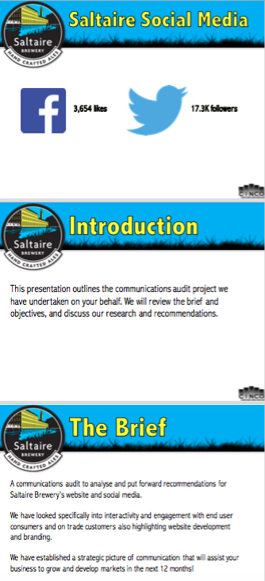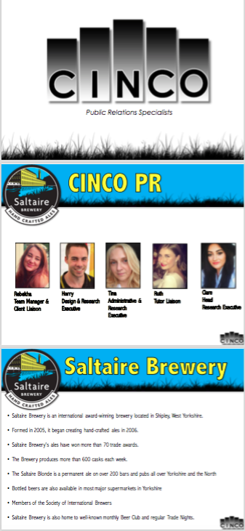**Appendix One: Presentation slides**

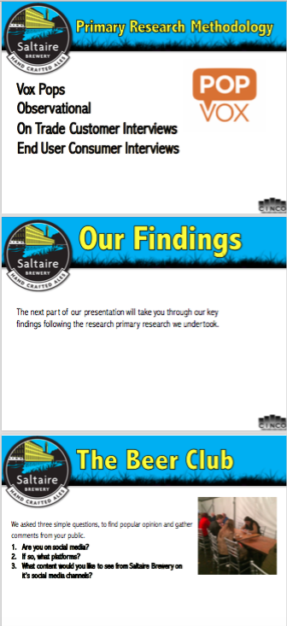

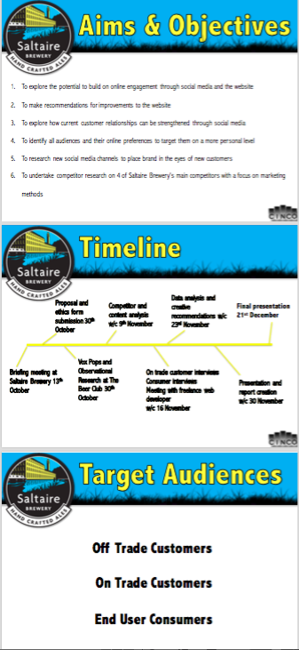

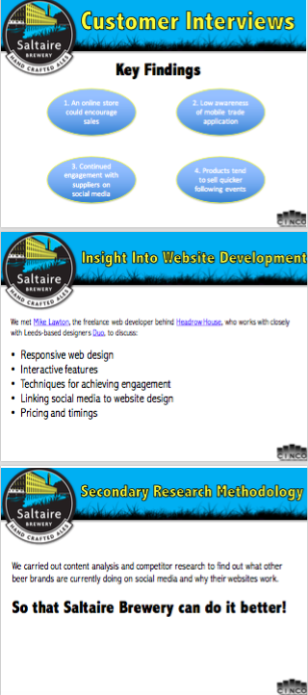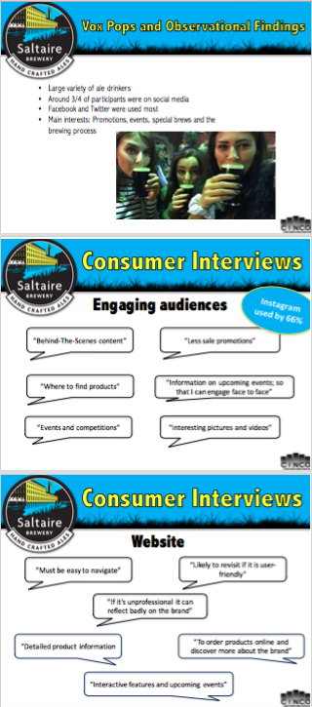

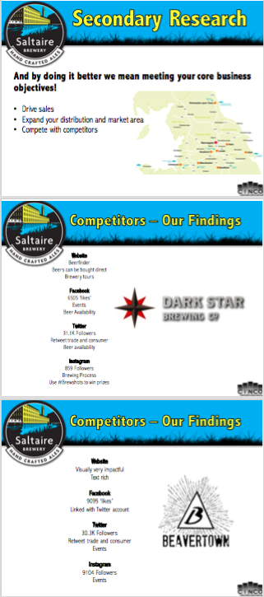

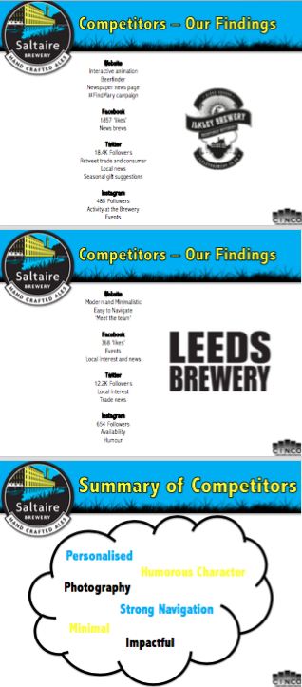

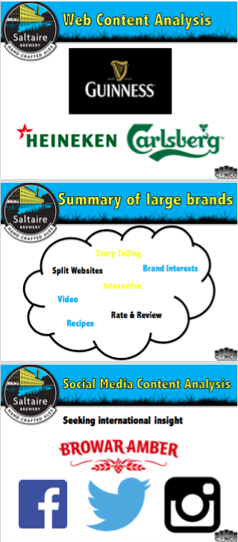

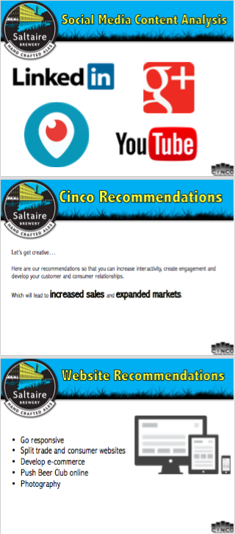

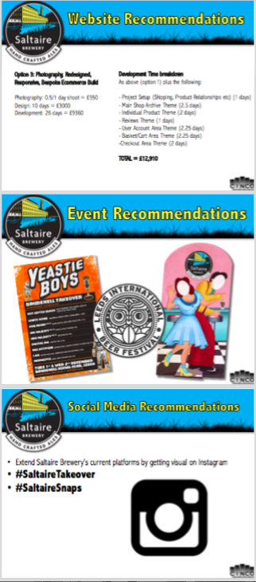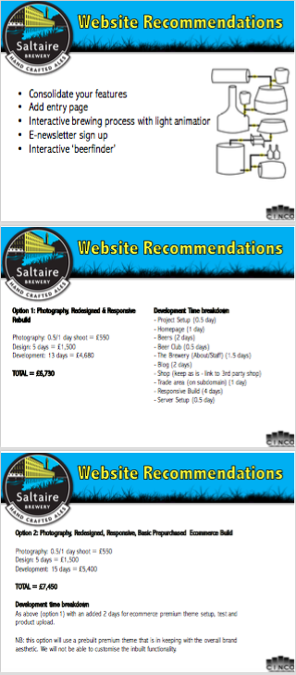

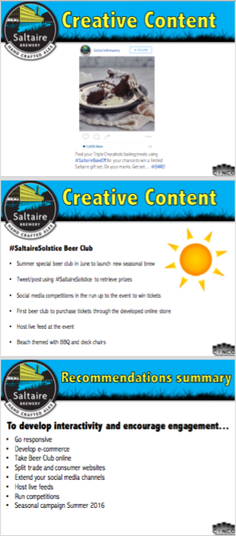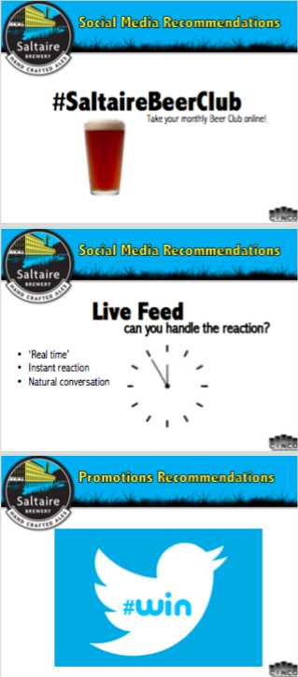

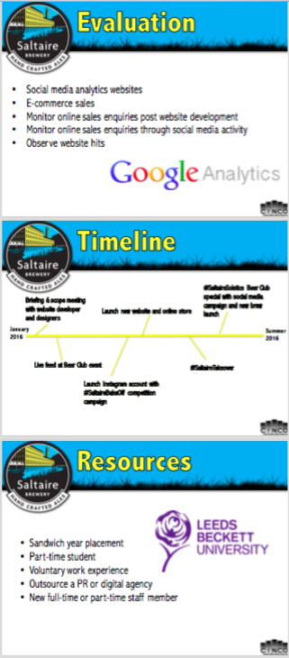

**Appendix. Two: Consumer Interviews  
  
Appendix 2.1.**

**Saltaire Interview Questions**

**End User Consumer Questions**

1. **Gender:**Male x▢  
   Female ▢

1. **Age:**18 - 30 x▢  
   31 - 50 ▢  
   51+ ▢

1. **Would you consider yourself an ale drinker?**Yes x▢  
   No ▢
2. **Where are you likely to buy ale/beer from?**

  Pub

1. **Do you follow any food or drink brands on the following social media platforms?**

Facebook x▢  
Twitter ▢  
Instagram x▢  
If more, please specify:

1. **How do you think brands could improve when engaging with audiences over social media?**

“Brands should make more of an effort to connect with audiences, rather than just sell to them”

1. **Does the design of a brand’s website ever alter how you feel about an organisation? If so, do you have any examples of this?**

  Yes. If a brand’s website looks unprofessional it makes me think that they might be unprofessional too. If the website looks good it shows that they have put effort into it, and that reflects well on them.

1. **What would encourage you to engage with a particular food or drink brand on social media?**

  Events or Competitions

1. **What are the main reasons you would visit a food or drink brand’s website?**

 Details on new products or to make an order  

1. **Would you firstly go to a brand’s social media channels or website for information and what information are you likely to be looking for?**  Depends on the information. If it was serious or in-depth information I would go to the website, but if it was information on an event or something that was happening at that moment, then I would go to the social media page.
2. **Would you attend a social media based event run by your favourite food or drink brand and, if so, why?** Yes, because it would be a chance to try new products.

**Appendix 2.2**

**Saltaire Interview Questions**

**End User Consumer Questions**

1. **Gender:**Male x▢  
   Female ▢

1. **Age:**18 - 30 x▢  
   31 - 50 ▢  
   51+ ▢

1. **Would you consider yourself an ale drinker?**Yes ▢  
   No x▢
2. **Where are you likely to buy ale/beer from?**

The pub

1. **Do you follow any food or drink brands on the following social media platforms?**

Facebook x▢  
Twitter ▢  
Instagram ▢  
If more, please specify:

1. **How do you think brands could improve when engaging with audiences over social media?**

They could post interesting pictures and videos from ‘behind-the-scenes’

1. **Does the design of a brand’s website ever alter how you feel about an organisation? If so, do you have any examples of this?**

  Sometimes. If a website is hard to use I will just go straight to a different website that’s easier.

1. **What would encourage you to engage with a particular food or drink brand on social media?**

 New announcements

1. **What are the main reasons you would visit a food or drink brand’s website?**

  Information on the product, or to see cool and interesting features on the website

1. **Would you firstly go to a brand’s social media channels or website for information and what information are you likely to be looking for?** Website, where I can buy the product
2. **Would you attend a social media based event run by your favourite food or drink brand and, if so, why?**  Yes, if it was free and I liked the brand because it could be good fun.

**Appendix 2.3**

**Saltaire Interview Questions**

**End User Consumer Questions**

1. **Gender:**  
   Male x▢  
   Female ▢

1. **Age:**  
   18 - 30 x▢  
   31 - 50 ▢  
   51+ ▢

1. **Would you consider yourself an ale drinker?**  
   Yes x▢  
   No ▢
2. **Where are you likely to buy ale/beer from?**The supermarket or the pub
3. **Do you follow any food or drink brands on the following social media platforms?**Facebook ▢  
   Twitter ▢  
   Instagram ▢  
   If more, please specify:
4. **How do you think brands could improve when engaging with audiences over social media?**More interesting content
5. **Does the design of a brand’s website ever alter how you feel about an organisation? If so, do you have any examples of this?**I’ll be more likely to revisit a website if it’s user-friendly
6. **What would encourage you to engage with a particular food or drink brand on social media?**Events or interactive competitions
7. **What are the main reasons you would visit a food or drink brand’s website?**To find out more about the history of a company and how it operates, and to buy their products.
8. **Would you firstly go to a brand’s social media channels or website for information and what information are you likely to be looking for?**Website, as it is hard to find key information on social media timelines.
9. **Would you attend a social media based event run by your favourite food or drink brand and, if so, why?**Yes. Hopefully there would be free tasters!

**Appendix 2.4**

**Saltaire Interview Questions**

**End User Consumer Questions**

1. **Gender:**Male
2. **Age:**18 - 30
3. **Would you consider yourself an ale drinker?**Yes
4. **Where are you likely to buy ale/beer from?**

I am most likely to but ale at pubs, in supermarkets, restaurants, at breweries and independent shops such at Tall Boys in Leeds.

1. **Do you follow any food or drink brands on the following social media platforms?**

I follow a number food and drink of Facebook and Instagram such as Saltaire Brewery, Tall Boys, Beer Ritz, Magic Rock Brewery and Northern Monk.

1. **How do you think brands could improve when engaging with audiences on social media?**

I personally would like to see more local brands putting on events as a way to engage with their local audience. I would rather engage with them in person at these events such as take over and sampling at pubs.

1. **Does the design of a brand’s website ever alter how you feel about an organisation? If so, do you have any examples of this?**Yes it does. For instance, I really like Magic Rock Brewing Company’s website. It is a strong brand, which is very enticing to ale drinkers like myself.
2. **What would encourage you to engage with a particular food or drink brand on social media?**I would be likely to engage with a particular food and drink brand through social media when they are advertising an event and running competitions. At work I would also do this to order samples, ordering stock and also for a further description on a product.
3. **What are the main reasons you would visit a food or drink brand’s website?**I would visit a website to find out the variety of beers on offer and to find out what events are on. When I’m at work at the pub I would also look to find the pump clips and research when new beers are coming out.
4. **Would you firstly go to a brand’s social media channels or website for information and what information are you likely to be looking for?**Website.
5. **Would you attend a social media based event run by your favourite food or drink brand and, if so, why?**Yes for pleasure – for example I would attend a brewery tour which is advertised through social media. I would be happy to post whilst at the event… free beer would be a plus!

**Appendix 2.5**

**Saltaire Interview Questions**

**End User Consumer Questions**

1. **Gender:**

Male ▢x

Female ▢

1. **Age:**

18 - 30 ▢

31 - 50 ▢x  
51+ ▢

1. **Would you consider yourself an ale drinker?**

Yes ▢x  
No ▢

1. **Where are you likely to buy ale/beer from?**

Pubs, mainly the old fasion type or a micro brewery pub

1. **Do you follow any food or drink brands on the following social media platforms?**Facebook ▢  
   Twitter ▢  
   Instagram ▢  
   If more, please specify:
2. **How do you think brands could improve when engaging with audiences over social media?**Inform the audience of the best places to try their beers and give discounts.
3. **Does the design of a brand’s website ever alter how you feel about an organisation? If so, do you have any examples of this?**There are a lot of very poor beers that have good adverts and so people drink it eg. Carlsberg & Fosters.
4. **What would encourage you to engage with a particular food or drink brand on social media?**  
   Discounts and offers
5. **What are the main reasons you would visit a food or drink brand’s website?**An event or a discount

1. **Would you firstly go to a brand’s social media channels or website for information and what information are you likely to be looking for?**No not unless it was informing of an event or a discount.
2. **Would you attend a social media based event run by your favourite food or drink brand and, if so, why?**Yes if it was a venue that was interesting or the event had something interesting about it.

**Appendix. 2.6.**

**Saltaire Interview Questions**

**End User Consumer Questions**

1. **Gender:**Female

1. **Age:**18 - 30

1. **Would you consider yourself an ale drinker?**No
2. **Where are you likely to buy ale/beer from?**I would be most likely to buy beer or ale from a supermarket or independent beer store.

1. **Do you follow any food or drink brands on the following social media platforms?**I tend to follow restaurants over brands on Instagram and I don’t use Twitter or Facebook as much as I use to.

1. **How do you think brands could improve when engaging with audiences over social media?**More promotions and where you can find products. Would rather engage with them at the shop, restaurant, pub or bar rather then on social. I tend complain to brands on social media.
2. **Does the design of a brand’s website ever alter how you feel about a brand? If so, do you have any examples of this?**Yes it would. Sticking to food and drink, after carrying out some research at university for one of my modules I really like the Leeds Beer Festival website.

1. **What would encourage you to engage with a particular food or drink brand on social media?**Good pictures, deals or an event.

1. **What are the main reasons you would visit a food or drink brand’s website?**Ordering, looking products or menu.

1. **Would you firstly go to a brand’s social media channels or website for information and what information are you likely to be looking for?**I would go to their website first. Information above.

1. **Would you attend a social media based event run by your favourite food or drink brand and, if so, why?**Yes I would, working in event management I’m always intrigued by new and original events – especially promoting local brands and giving discounts!

**Appendix. 3.0: Customer Interviews**

**Appendix 3.1**

**Saltaire Interview Questions**

**Trade Customer Questions**

1. **What is your occupation?**  Pub Owner
2. **Have you ever stocked Saltaire Brewery products?**  
   Yes ▢x  
   No ▢
3. **What methods are you likely to use when ordering stock from a local brewery?** Phone

1. **Would an online method for ordering encourage you to stock more Saltaire Brewery products?** If it was simple and easy to use, then yes

1. **What would encourage you to engage with a beer brand on social media?** If they were active online and promoted the fact that we sell their beer
2. **What are the main reasons you would visit a beer brand’s website for?** To check out details on new products, and sometimes, to order
3. **Following a brand hosted beer event or social media campaign, have you seen a rise in interest for that particular brand or product?** Yes, definitely. When we have a beer on cask it usually then helps with sales of cans or bottled products. After an event where people are able to try new ales, we often restock products from these brands to meet people’s requests and demands.

**Appendix 3.2**

**Saltaire Interview Questions**

**Trade Customer Questions**

1. **What is your occupation?**  
   Bar Manager
2. **Have you ever stocked Saltaire Brewery products?**  
     
   Yes ▢x  
   No ▢
3. **What methods are you likely to use when ordering stock from a local brewery?**Phone
4. **Would an online method for ordering encourage you to stock more Saltaire Brewery products?**Yeah, for sure. This would be a really convenient way to order.
5. **Are you aware of Saltaire Brewery’s mobile trade application for ordering products?**

No

1. **What would encourage you to engage with a beer brand on social media?**  
   Two-way communication, regular updates, and new ideas
2. **What are the main reasons you would visit a beer brand’s website for?**   
   New products, more extensive information about a product, prices, and offers
3. **Following a brand hosted beer event or social media campaign, have you seen a rise in interest for that particular brand or product?** Haven't had one where I work, but I have definitely noticed the effect of it elsewhere.

**Macintosh HD:Users:harrytidswell:Desktop:UNI:Leeds Food Bloggers Print-out.pdfAppendix 4: Food Bloggers**

**Appendix 5: Photo Opportunity Examples**

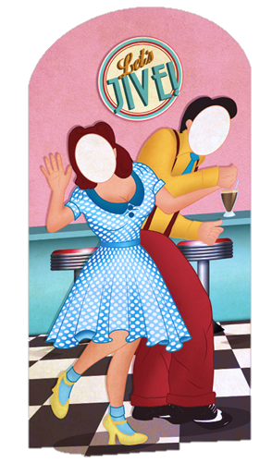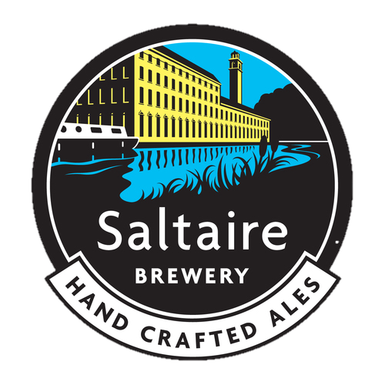

**Appendix 6: Website screenshots**

**Appendix 6.1 – Darkstar**

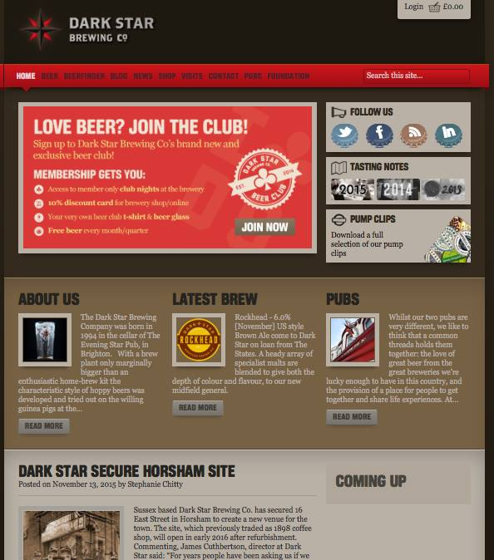

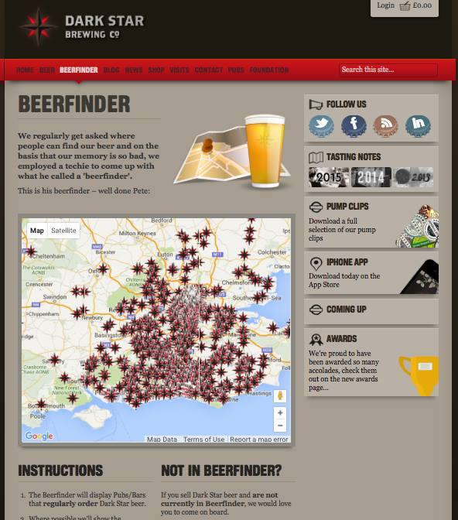

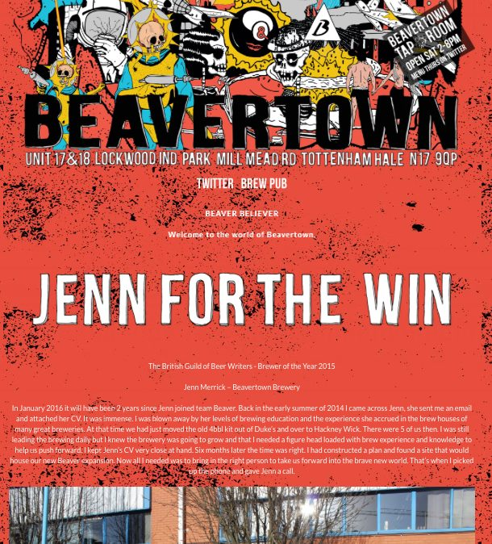**Appendix 6.2 – Beavertown**

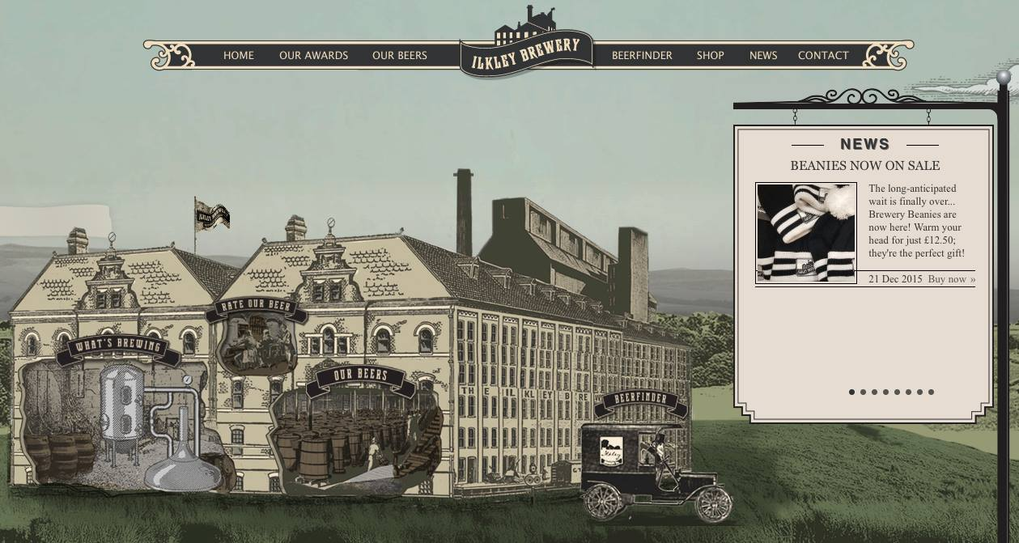**Appendix 6.3 – Ilkley Brewery**

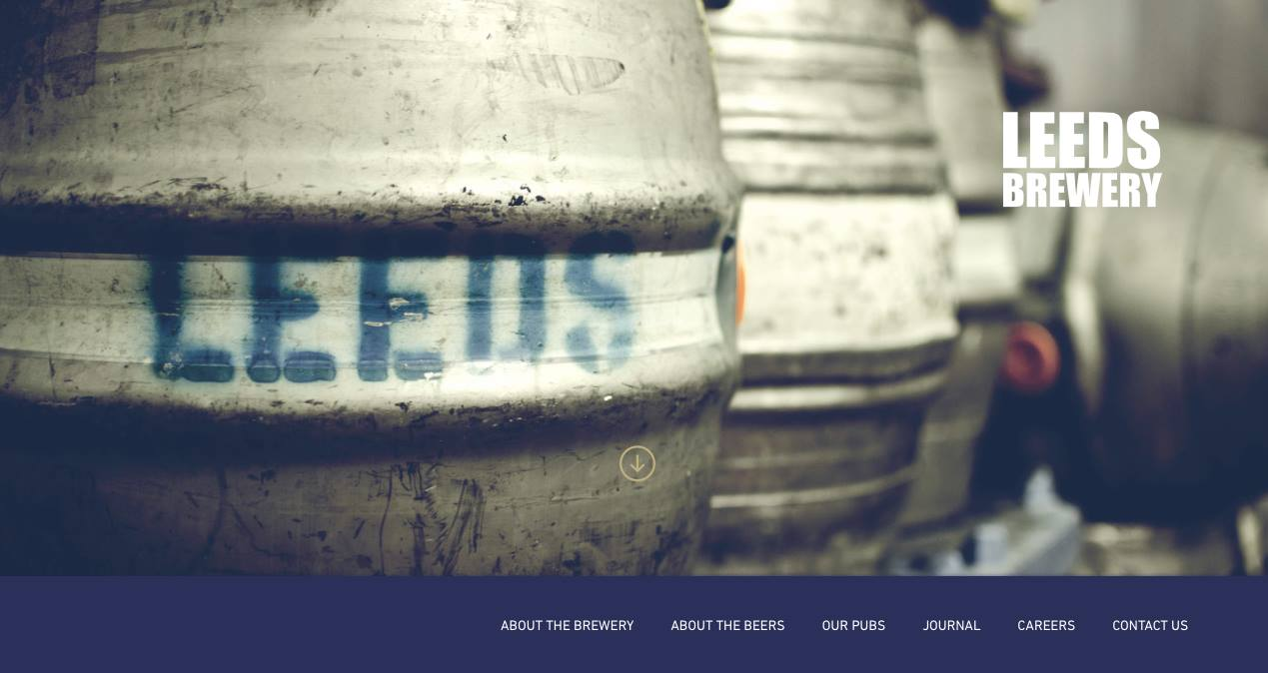**Appendix 6.4 – Leeds Brewery**

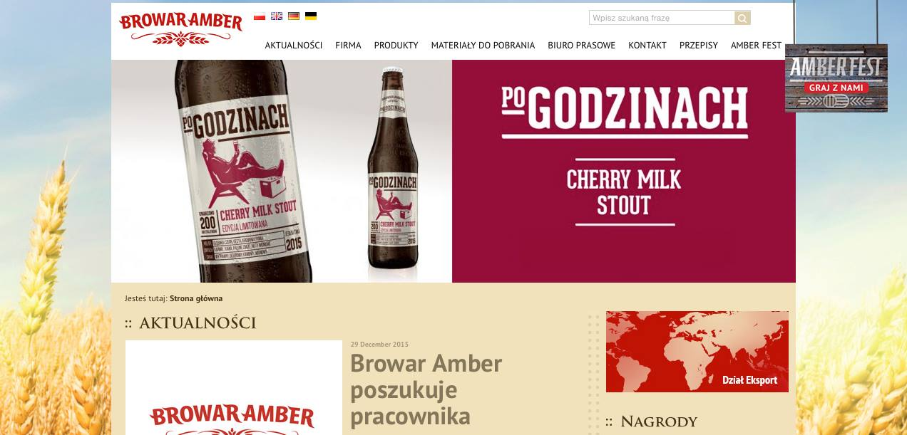**Appendix 6.5 – Browar Amber**